School Management System
Theme
A school wants to maintain student details, subjects, exams and the marks scored by students in each exam.
Modules
- Students
- Subjects
- Exams
- Marks

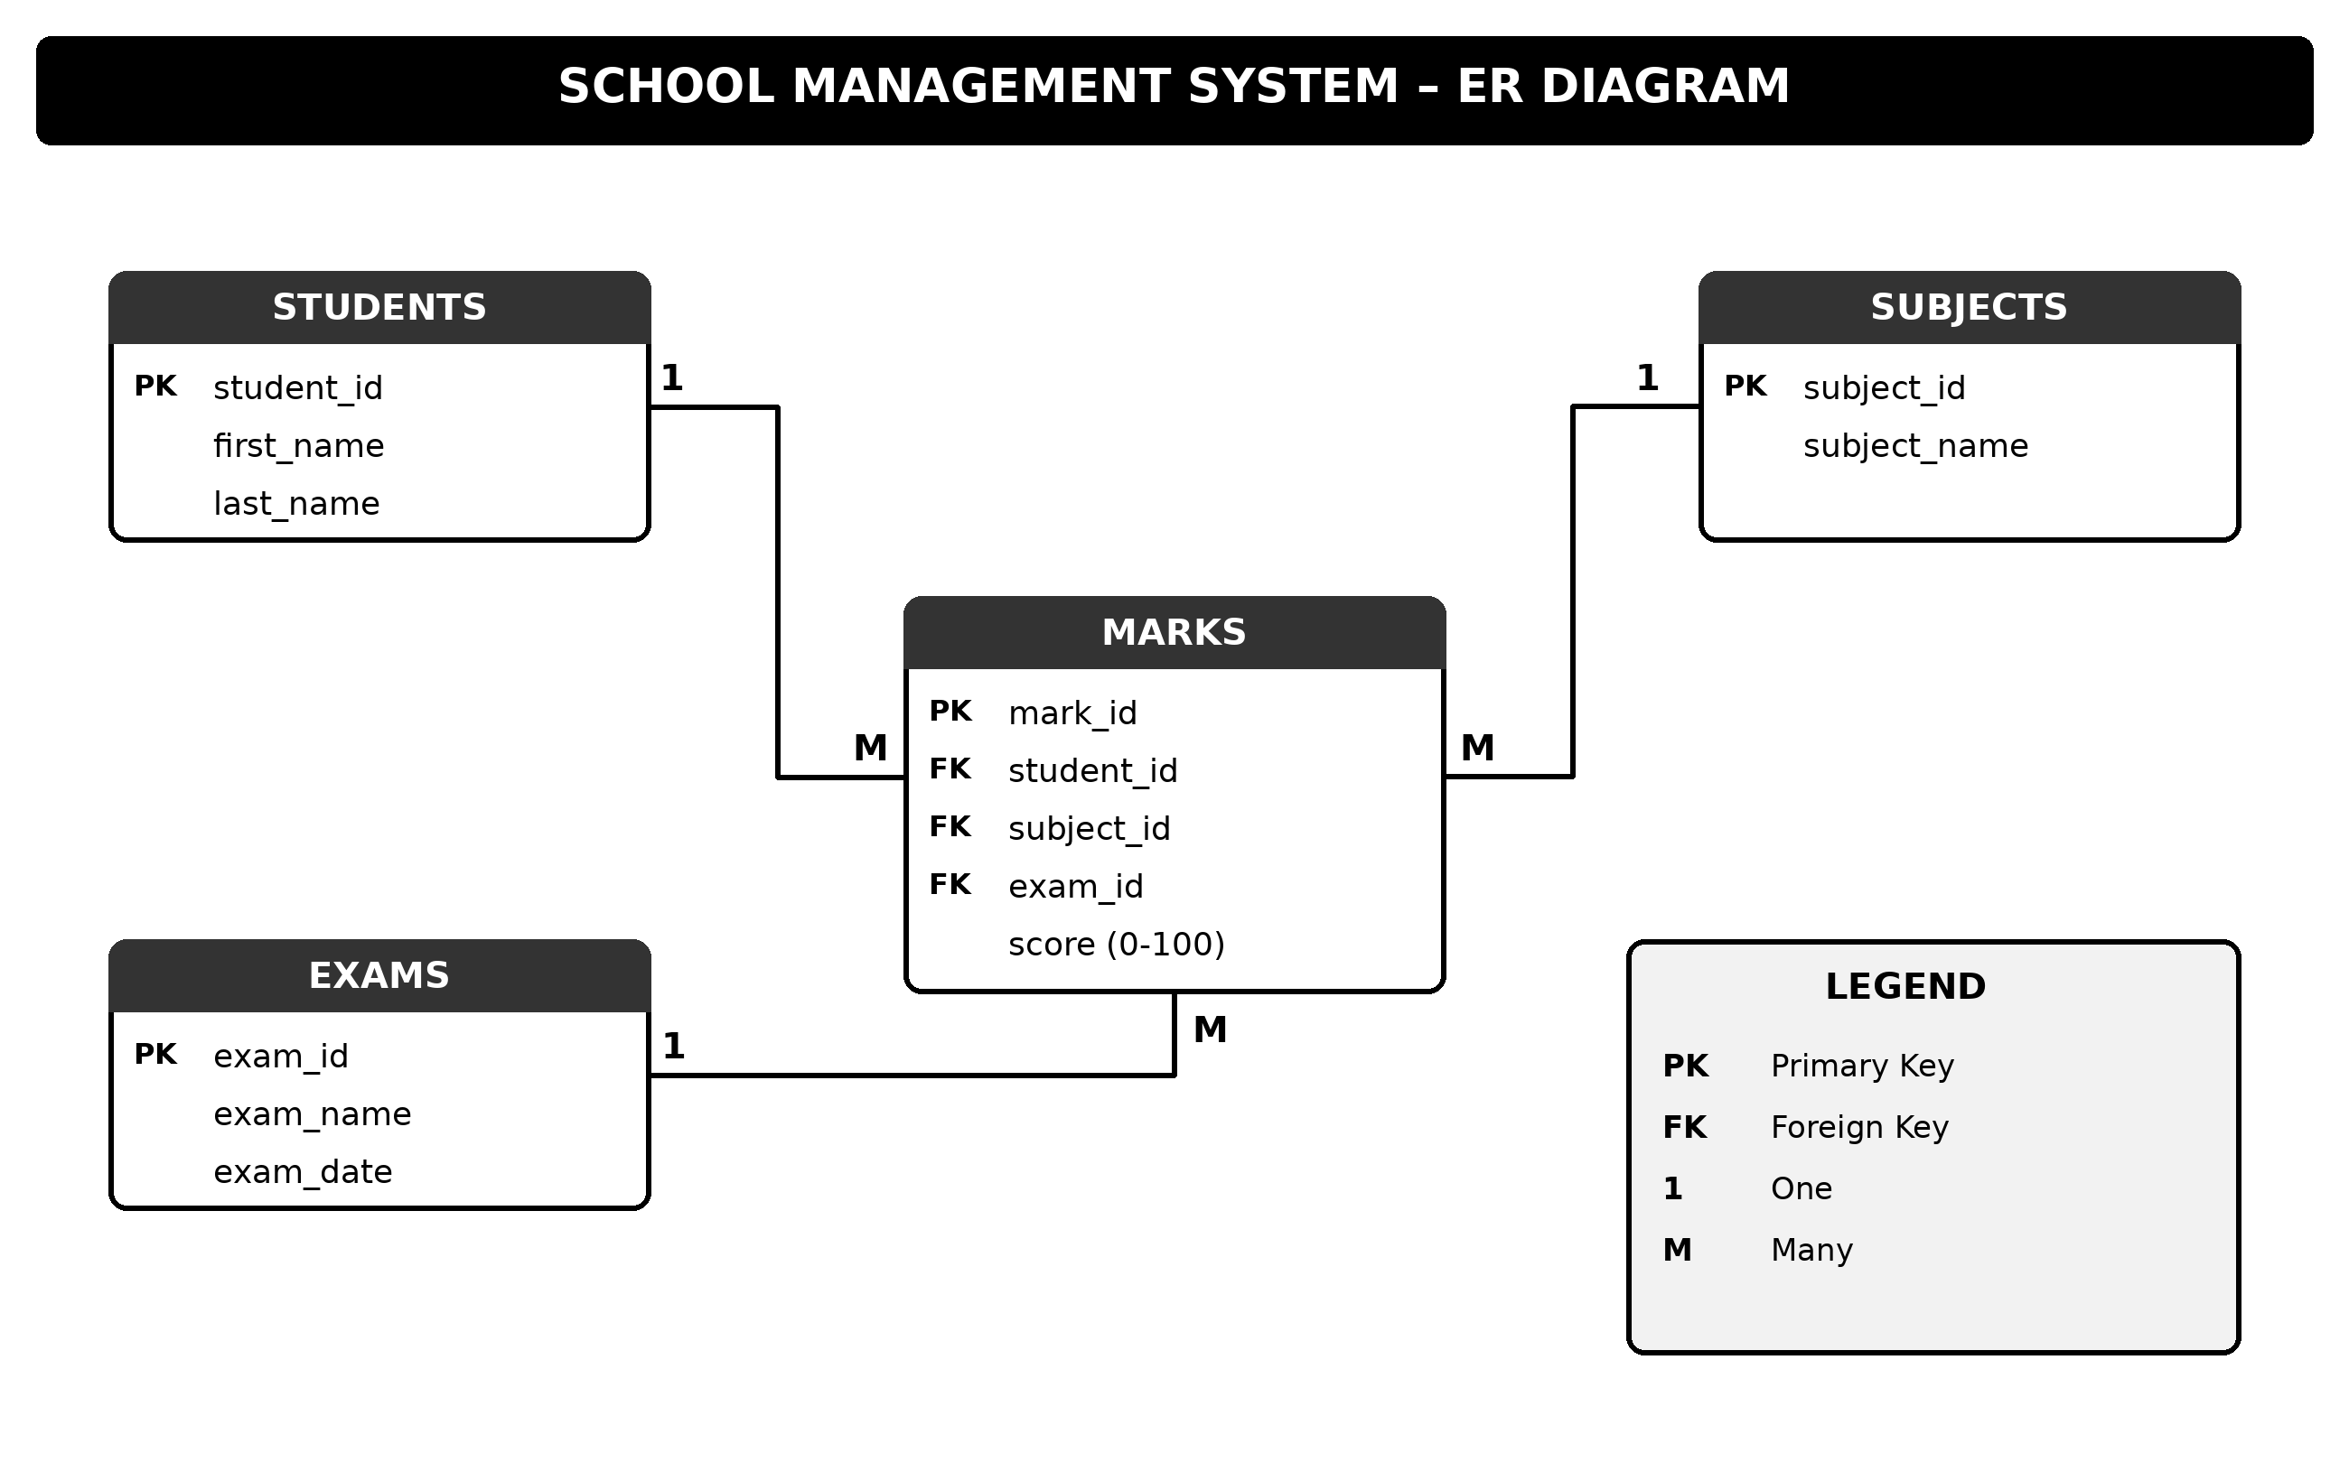
Sample Data
STUDENTS
ID | First Name | Last Name
1 | Aarav | Sharma
2 | Priya | Patel
3 | Rohan | Verma
4 | Ananya | Singh
5 | Karthik | Reddy
6 | Sneha | Iyer

SUBJECTS
ID | Subject Name
1 | Mathematics
2 | Science
3 | Hindi
4 | English
5 | Social Studies

EXAMS
ID | Exam Name | Exam Date
1 | Unit Test 1 2024 | 2024-07-15
2 | Half-Yearly 2024 | 2024-10-10
3 | Annual 2025 | 2025-03-20

MARKS
ID | Student ID | Subject ID | Exam ID | Score
1 | 1 | 1 | 1 | 78
2 | 1 | 2 | 1 | 85
3 | 2 | 1 | 1 | 60
4 | 1 | 1 | 2 | 92
5 | 1 | 2 | 2 | 88
6 | 1 | 3 | 2 | 76
7 | 2 | 1 | 2 | 81
8 | 2 | 4 | 2 | 69
9 | 3 | 2 | 2 | 55
10 | 4 | 3 | 2 | 90
11 | 5 | 5 | 2 | 72
12 | 1 | 4 | 3 | 84
13 | 2 | 2 | 3 | 73
14 | 3 | 1 | 3 | 48
15 | 4 | 5 | 3 | 95
16 | 6 | 3 | 3 | 67

Queries
- Retrieve the first name and last name of all students.
select first_name, last_name from students;
- Display all marks where the score is greater than 80.
select * from marks where score > 80;
- Display all exams sorted by date, most recent first.
select * from exams order by exam_date desc;
- Display the first name, subject name and score for every mark.
select s.first_name, sub.subject_name, m.score
from marks m
join students s on m.student_id = s.student_id
join subjects sub on m.subject_id = sub.subject_id;
- Find the average score of each subject.
select sub.subject_name, avg(m.score) as average_score
from marks m
join subjects sub on m.subject_id = sub.subject_id
group by sub.subject_id, sub.subject_name;
- Count how many marks are recorded for “Aarav Sharma”.
select count(*) as total_marks
from marks m
join students s on m.student_id = s.student_id
where s.first_name = 'Aarav' and s.last_name = 'Sharma';
- Find the student with the highest single score in any exam.
select first_name, last_name
from students
where student_id in (select student_id from marks
where score = (select max(score) from marks));
- Display the exam name and total score, only where the total score is greater than 250.
select e.exam_name, sum(m.score) as total_score
from marks m
join exams e on m.exam_id = e.exam_id
group by e.exam_id, e.exam_name
having sum(m.score) > 250;
- Display the student name, subject, score and Pass/Fail status (Pass if score is 70 or above).
select concat(s.first_name,' ',s.last_name) as student_name,
sub.subject_name,
m.score,
case when m.score >= 70 then 'Pass' else 'Fail' end as status
from marks m
join students s on m.student_id = s.student_id
join subjects sub on m.subject_id = sub.subject_id;

